

BOOK ECOMMERCE SYSTEM

By

ROBEL ARAIA ISAK KINFE

Dissertation Submitted to Faculty of Engineering, Science & Technology (FEST), Infrastructure University of Kuala Lumpur, in Fulfilment of the Requirements for the Bachelor of Information Technology (Hons) in Network Technology.

June 2021

**ACKNOWLEGEMENT**

All praise be to God for all the things throughout my journey of knowledge exploration to complete this project. I would like to express my sincere gratitude to my supervisor for his guidance and advices throughout this work to make it successful. My deepest appreciation to my family especially my parents for their utmost support and encouragement without them all these would not be possible. Last but not least, many thanks and appreciation to all my friends for helping me with a lot of ideas, motivations and encouragements

ABSTRACT

Nowadays, the network plays an import role in people’s life. In the process of the improvement of the people’s living standard, people’s demands of the life’s quality and efficiency is more higher, the traditional bookstore’s inconvenience gradually emerge, and the online bookstore has gradually be used in public. The online bookstore is a revolution of book industry. The traditional bookstores’ operation time, address and space is limited, so the types of books and books to find received a degree of restriction. But the online bookstore broke the management mode of traditional bookstore, as long as you have a computer, you can buy the book anywhere, saving time and effort, shortening the time of book selection link effectively. The online bookstore system based on the principle of provides convenience and service to people.

Table of Contents

Chapter 1

1.1 Introduction5

1.2 Background study 5

1.3 Problem statement 6

1.4 Manual book search7

1.5 Payment 7

1.6 Objective 8

1.7 Scope 8

1.8 Gantt Chart 9

1.9 Hardware requirements10

1.10 Software requirements10

Chapter 2 11

2.1 Introduction11

2.2 Comparison to existing system11

2.3 Books kinokuniya12

Figure 2.1 Books kinokuniya13

2.4 Mph online14

Figure 2.2 Mph online15

2.5 Comparison table15

2.6 Development tools 15

2.7 User requirements 15

2.8 Functional requirements 16

2.9 Non- Functional requirements 17

Chapter 318

3.1 Introduction 18

3.2 Chosen Methodology 18

3.3 Use case diagram19

Figures 3.1 Use case diagram19

3.4 Use case description20

3.5 Sequence diagram21

Figures 3.2 Sequence diagram 1 21

Figures 3.3 Sequence diagram 222

3.6 Class diagram23

Figures 3.4 Class diagram23

Conclusion24

Chapter 418

Chapter 518

Chapter 618

Reference18

# **Chapter 1** **introduction**

## 1.1 Introduction

Customers and managers can both sign up and login to the Book Ecommerce system. It is a basic, unique, and easy-to-use structure for even the most inexperienced user. Customers will sign up them and be forced to join their information for the next step in the method. Online systems have a lot of cool functionalities, such as the opportunity to buy reading material, sell books, become participants, display available books, and keep track of clients.

Customer can sell and buy their book and select from a variety of payment choices. Customers will be able to scroll, find, pick, and insert books to their shopping carts using the system. The system places books in the shopping cart of the customer. The system also provides managers with the ability to produce, retrieve, update, and remove data.

## 1.2 Background study

There has been a lot of progress in the field of design and architecture and fundamentals in the universe of application advancement. As the ones in power of the software's modernization change, so do the ideologies and technical requirements. Many designers use tried and proven design trends and application advancement guidance in this wonderful and oftentimes complicated universe of application advancement. In addition, your layout must be capable of turning toward advancement rather than conforming to standard tactics. Internet services are one example of an area where designers must rely on their creativity and wish that their methods are still effective.(Ming Cui, Jiali Yu, 2020)

The emergence of computers into communication industry has dramatically enhanced organizations’ data needs; the achievement of this device is reliant on the skill set. As a result, one might be urged to ask aloud, "What is a computer?" Funk (1980) described a computer as an electronic gadget that can undertake a series of logical operations instantly and at fast speed in response to directions provided to it in the shape of a pre-programmed program.

A compared of conventional and fusion online systems in technology, as per Jeremy V Ernest. The internet scheme has are becoming a core component of the discussion about relatively high teaching (cox 2005). Due to the critical demand for planning versatility and the everyday crisis of interaction technological advances and skills, there appears to be a general trend toward online systems (Wheelen et al, 2017).

Retail stores, as a retail market, have grown quickly as a result of consumer modernization and urbanization. The establishment of bookstores in shopping centers is viewed as an inventive move in the retail sector. This paper examines business model in the context of new retail by using Sisyphe bookshop as the research area. Sisyphe bookstore is the market leader in the chain tangible bookshop sector. The foundation of new department stores is the online world. Retailers use innovations like big data analysis, cloud services, intelligent systems, virtual worlds, and other technological innovations to encourage offline stores and realize O2O enterprise. (Y. Wang, D. Xu, 2021)

There has been a lot of advancement in the field of design process and fundamentals in the universe of software’s innovation. As the ones in power of the software's improvement change, so do the ideologies and hardware execution. Most designers use tested and true design trends and application development standards in this wonderful and often complicated software world. In addition, your layout must be capable of turning forward into advancement rather than conforming to familiar practices. (ETDA, 2019)

Online bookstore managers handled the aspects influencing the achievement of the online bookstore industry in aspects of effectiveness, particularly the capacity to handle costs at a moderate level. This suggests that price decrease and efficiency gains in online book selling are more challenging to achieve because the books are low-cost products with high mass, resulting in overheads for storage and logistic support, particularly for small transportation that necessitates assistance from production and delivery suppliers and indictments shipping costs terms of weight. (Chen et al, 2021)

Web services are one example of an area where designers must rely on their creativity and wish that their methods are still effective. We will describe an exciting journey down the track of Web applications application in this study. We will handle all aspects of systems engineering necessary to construct an implementation with cooperative Web applications, from prerequisites to use cases, database design, component structures, and interface design.

We chose Book ecommerce system because everyone on the roadside knows something about bookshops. The purpose of the proposal is to create an e-book store where publications can be purchased from the ease of one's own residence via the Web.

## 1.3 Problem statement

There are several problems that customer has to face when they are looking for a book store. Below are the problems described that customer experience.

**Location**

One of major the problems is finding nearest book store when a customer wants to purchase a buy they will first search for the location of book store. If a customer visits another city, state or country this will be a major hurdle in buying book from store.

**Manual book search**

Another problem is to find the desired book in store. Customer will have to explore the store to search for the required one. This is waste of time in this busy world. Moreover visit to a store takes time if book store is far away from one’s residence.

**Payment**

In this era of digital world customers purchase almost everything online to save time and effort. They use several payment methods to make purchase. Most book stores offers cash payment which is problem for some customers.

**Waiting in queue**

When customers manually visits book store they may have to wait for hours because there can be several other customers. Book store deals customers on first come first serve basis which can be annoying sometimes if you have to go to somewhere urgently.

## 1.4 Objectives

Objectives of the book ecommerce system are:

* To develop Online Computer Book Store Management System. The management includes following features

1. Includes admin and multiple clients

2. Account maintenance

3. Purchase Book

4. Review books

* To develop customized searching of books based on specialized classification. User can search book by title, author, publisher etc.
* To send updates (Promotions and discount) to the customer's one Social media platform. System will send information about new arrivals , discounts to WhatsApp / Telegram.

## 1.5 Scope

* Any customer will be eligible for membership and become a user through the Book E-Commerce System.
* The consumer will have the choice to become a participant of the webpage during the account registration procedure.
* Customers will be able to scroll, find, pick, and insert reading material to their shopping trolleys using the system. And after that, if they have reading material in their cart, check out the reading material in their shopping cart and decrease the amount of inventory that the system has retains.
* The BECS also helps management to handle the stock by providing complete generate, collect, modify, and remove features for documents in the process.
* It will also encourage clients and management staff to communicate with an advertising system that controls promotional offers that can be practiced to participant purchases on a stock basis.
* User can also open dispute on order if some mishandling occurs during shipment.

## 1.6 Gantt chart

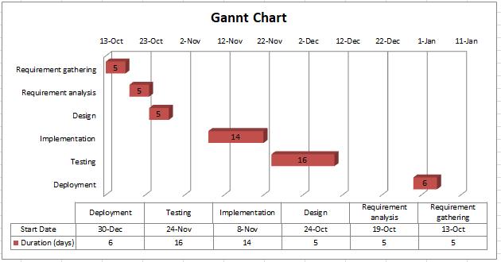

## 1.7 Hardware requirements

|  |  |
| --- | --- |
| Processor | i3 |
| Hard Disk | 5 GB |
| Memory | 1GB RAM |
| Printer | Colored/black-white |

## 1.10 Software requirements

|  |  |
| --- | --- |
| Server | XAMPP |
| Code Editor | Adobe Dreamweaver |
| Operating System | Windows 10 Enterprise |
| Database software | MySQL |
| Web browser | Google Chrome |

## CHAPTER 2

**LITERATURE REVIEW**

## 2.1 Introduction

An Ecommerce book system is a web application that allows customers to buy and sell books online. Buyers can use an internet browser to search for a book by label or writer, add it to their shopping basket, and then pay with a bank card. The visitor can log with using his account information, or new people can simply signup. They must provide their identity, phone number, and delivery address. The customer can also provide reviews to a book by rating it on a scale of 1 to 5. The records are classified into several classifications relying on their subject, such as operating system, databases, English, and design.

In this section comparison study will be performed for existing process of book purchase. Moreover development tools will be analyzed that will be used for development of Ecommerce book system. Functional, non-functional and user requirements are analyzed in this chapter.

## 2.2 Comparison to existing system

Ecommerce book system, as opposed to conventional bookshops, can prevent the constraints and visual impairment of catalogue requests. They can also conquer the scarcity of huge information, increased price, and tough monitoring. And because a broad variety of internet possibilities can be viewed visibly, prepared to purchase, comfortably, and rapidly, these benefits are unrivalled by other trading methodology. As a consequence, book electronic retailing is an unavoidable prospective advancement of the print sales profession; this is the only method for the book sector to build new disperse streams.

The physical book buying operation is inefficient for both shop owners and clients, as they must interact with crowds in their stores. The traditional techniques are divided into two categories, the most famous of which was going to the store and asking the shop owner for the diary. Whether he has that book, he will offer it to you and ask for cash, which may be more of it than you anticipated. The other option is to approach a wholesaler or shop owner straight via phone asking him to deliver the publications to your location in exchange for money and the additional convenience fees of shipping.

### 2.3 Books kinokuniya

kinokuniya book store is a famous book store in Malaysia. It offers the selling of books to users in different languages. Their website sells Asian books, music CD, magazines etc User can register in the system and can search for books he wants to purchase by adding them to cart. But this system does not allow user to sell their second hand books on the website. It has no review system available.



  
Figure 2.1 Books kinokuniya

### 2.4 Mph online

Mph online book store is a well-known book store in Malaysia. It offers the selling of books to users in different languages. Their system provides a lot of books category such as Chinese, non- fiction, fiction books and children books etc. User can register in the system and can search for books he wants to purchase by adding them to cart. But this system does not allow user to sell their books on the website.

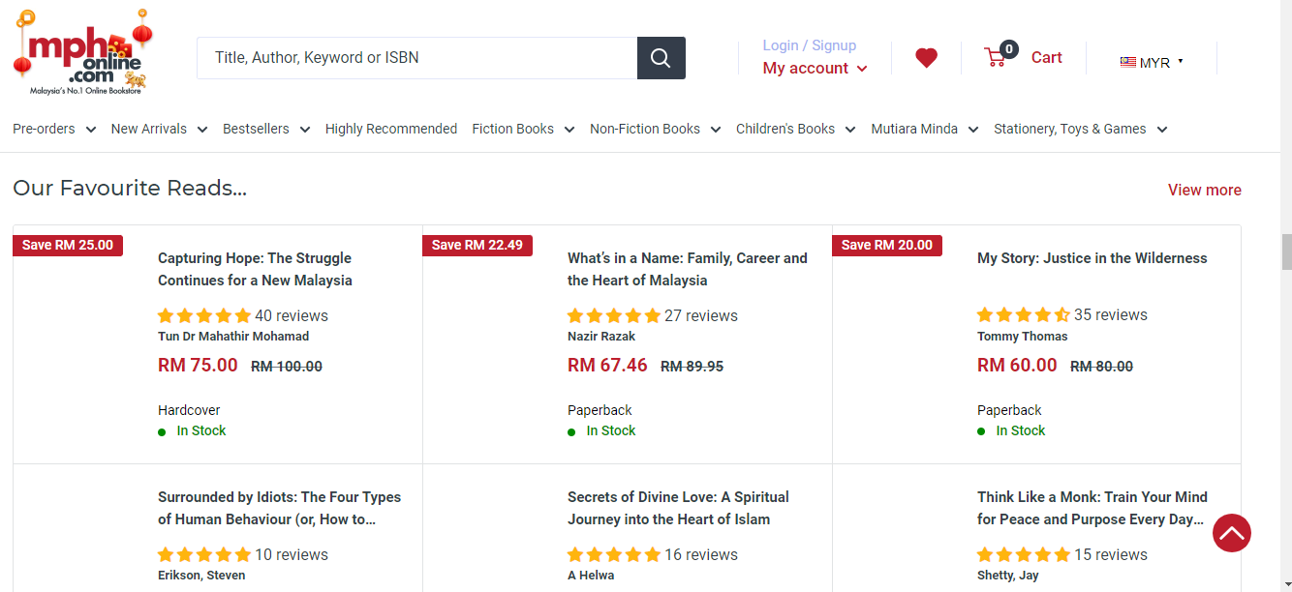

Figure 2.2 Mph online

### 2.5 Comparison table

|  |  |  |  |
| --- | --- | --- | --- |
|  | **Kino kuniya** | **Mph online** | **Ecommerce book system** |
| **Registration** | Yes | Yes | Yes |
| **Cart** | Yes | Yes | Yes |
| **Search feature** | Yes | Yes | Yes |
| **Feedback** | No | Yes | Yes |
| **Sell book** | No | No | Yes |
| **Purchase book** | Yes | Yes | Yes |

## 2.6 Development tools

### MySQL

MySQL will be used as the back - end database in this venture. Mysql is a relational database structure that is free and open source. MySQL's characteristics are as follows:

* Mysql is the most popular system that uses a relational model. Instead of storing information in a single large table, a relational database stores it in multiple tables. Such tables can be linked together to make it easier to obtain and handle data.
* MySQL is a free and open source database. Anybody can use and alter the database software to address the specific needs. It is quick, dependable, and simple to use. It is used to increase effectiveness.

### Microsoft Office

Microsoft Office 2013 developed by Microsoft provides an office tool for users to manage and create documents like reports, proposals, thesis, and more. Microsoft provides a long-term reuse of data with no lock-in to proprietary tools or undocumented format. This allowed the document to be open and use for a year without change for document format type. This tool is important for the project to create a proposed document to be documented and (Casson &amp; Ryan, 2006) review for the project manager and project team.

### Microsoft Project

It is a tool to develop Gantt chart and Project Scheduling for projects. This assists project managers to handle different projects effectively at a point of time. (CEMBS, 2014) This tool enables project managers and project team to track the time and completion date accurately and avoid wastage of time to complete the project.

### XAMPP Server

It is a useful tool for running and simulating a desktop as a server and enabling the site to be tested to see if the records on the server can operate without requiring a network connection. The spine of the life cycle of the project for open source web application progression is a contrary model that provides a web server, a repository, and a coding engine or computer language preprocessor.

## 2.7 User requirements

1. Register-In attempt to gain access, the user must first sign up.
2. Login: To gain entry to the process, users must first log in.
3. View product-The user can observe various products and their information in this.
4. Lookup –The user can search for books by title, and can add them to cart.
5. Payment- User can do the payment of book purchased.

## 2.8 Functional requirements

This system includes the following features:

### Book catalogue on the main page

After an initial authentication, the customer will be directed to this screen. It will showcase all of the book classifications as well as a lookup search term choice for finding the desired book. It also has some specific segments, such as suggested names and weekly specific articles.

### Search for book

A block can be used to provide the customer with a hashtag search feature. The book description should be registered as the search term.

### Book Synopsis

If a customer wants to learn more about a book, he can select on the label, which will take him to a Book specification section. It contains the book's information notes and there is also a connection to Amazon.com where you can read the review of a book.

### Review by Users

The customer can rate a series centered on his or her interests. He can evaluate it by assigning a rating to it. five stars for Brilliant, four stars for Very Nice, three stars for Good, two stars for Regular, and one star for Poor inadequate. The last rank of a book will rely on all the specific buyer score.

### The Shopping Cart

The customer can handle a shopping cart that contains all of the books he has chosen. The customer has the ability to modify, remove, and refresh his cart. A final shopping trolley overview is showcased, which contains all of the books chosen by the user as well as the full expenses.

### User profile administration

To use all of the blog's features, every customer must create a profile. The login page is used to log in, and the logout page is used to log out. The system will store all user activities.

## 2.9 non-Functional requirements

### Compatibility

Making sure your web application looks good on all web browsers is an important 1st move toward top notch website designing. Even so, surfing the web isn't the only predator that exists these times. Individuals now use their smartphone, tablet devices, gaming systems, and even wearables to surf the web. So, this website will be compatible on all browsers.

### Performance

The achievement of any website, and how rapidly the sites load and function, is an essential but difficult measurement to measure. With more individuals accessing the internet via smart phones, the requirement for quick and data-light websites is obvious. Our active monitoring process will results the best performance of this site.

### Usability

Usability of our website will be extremely user friendly and efficient. All the related options will be displayed as a drop down menu.

### Accessibility

Our website will be accessible from everywhere regardless of platform and location dependency. It can be accessed anytime and everywhere is the globe.

# **cHAPTER 3**

# **Methodology**

## 3.1 Introduction

### The term "research method" relates to the complete "how" of any specified literature review. It is about "how" an analyst models a survey in a structured manner to make sure precise outcomes that discuss the goals and desired outcomes. A decent survey technique can help you paint a picture of your task. If you are carrying out a task, the first process is to determine the best direction to evolve the proposal. The primary goal of research methods is to ascertain which methods will be used to complete the proposal. Approaches are classified into numerous kinds. In this section, we'll talk about the methods we chose for our venture or why we chose it.

### 3.2 Chosen Methodology

There are numerous project control methods available, ranging from waterfall to agile to agile methodology that can be used to maximise achievement. It is the program management group's obligation to select the appropriate method. There really is no other path to ensure the accomplishment of a scheme than to run it through the stages of any methodological framework. The RAD technique is appropriate for Ecommerce book systems. There is no other method to run a project than to initiate from the start; you must always pick an approach that meets all of your task's requirements.

### RAD

Rapid application development (RAD) is a production life span that is designed to provide a quicker and higher-quality technology platform than the conventional product lifecycle. Book Ecommerce system use the RAD technique because it is a people-centered and gradual production strategy that involves clients throughout the development of a structure and fosters collaboration among all relevant parties. Testing is performed throughout the development process, so that the below implementation project is evaluated and assessed progressively by designers and consumers. RAD is a process that allows organizations to evolve smartly essential systems more quickly while lowering advancement costs and preserving reliability.

### 3.3 Use case diagram

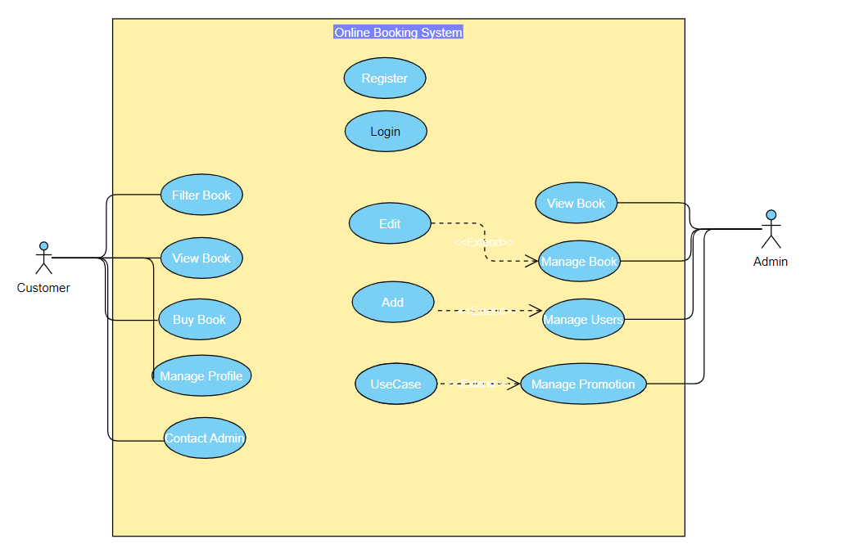

Figures 3.1 Use case diagram

Use case model shows the process of book Ecommerce system. There are two actors in this system customer and admin. Customer/User and admin both can register on the system and after registration they can login into system. User can search for books by their author name or ISBN and can add them to cart. User can also add books to the system for purchase. This system works for selling and purchasing of books online. User can pay via credit card. User can give review of the books purchased. On the other hand, admin can handle all the activities happening on system and can accept or review the book that user wants to add for sell.

### 3.4 Use case description

|  |  |
| --- | --- |
| **Field** | **Description** |
| Use case Title | Use case of Customer actions |
| Actor | Customer |
| Preconditions | Customer must have valid Account |
| Trigger | Customer Log in to the system |
| Success Scenario | * Login to the system * Search books * Select book to purchase/sell * Add books to cart * Payment * Log out |
| Extension | * All the data are record in database * System update |

|  |  |
| --- | --- |
| **Field** | **Description** |
| Use case Title | Use case of Admin actions |
| Actor | Admin |
| Preconditions | Admin must have valid Account |
| Trigger | Admin Log in to the system |
| Success Scenario | * Login to the system * Add new book to sell * Manage customers * Review books * Log out |
| Extension | * All the data are record in database * System update |

### 3.5 Sequence diagram

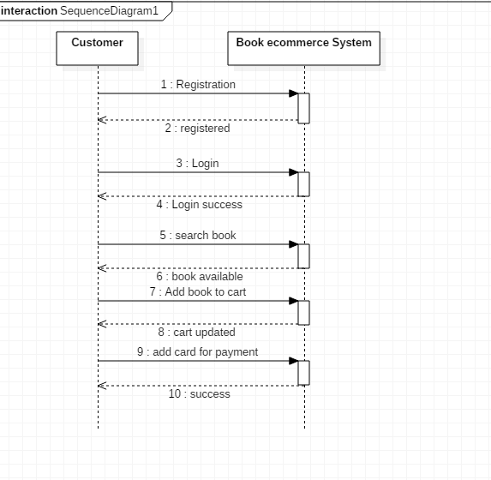

Figures 3.2 Sequence diagram 1

The above figure shows the sequence of activities when a customer interacts with the system. Customer can register, login and search for books by their author name or ISBN and can add them to cart. Customer can also add books to the system for purchase. This system works for selling and purchasing of books online. Customer can pay via credit card. Customer can give review of the books purchased.

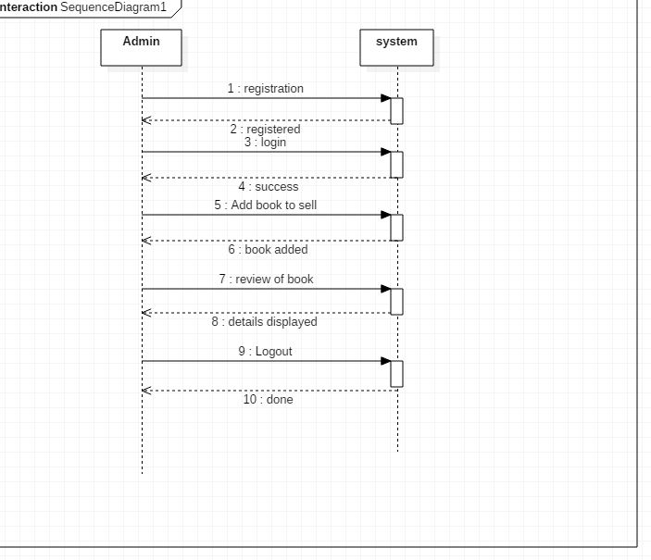

Figures 3.3 Sequence diagram 2

The above figure displays the sequence of activities between system and admin. Admin can login to the system after registration. Admin can add new books and can check the reviews about books.

### 3.6 Class diagram

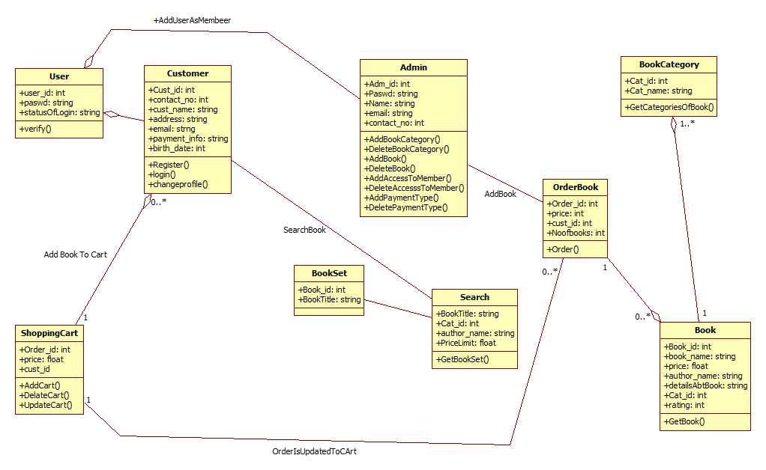

Figures 3.4 Class diagram

Above diagram is a class diagram of book ecommerce system. There are 5 entities in this system and each entity has some unique attributes and operations specified. All the classes are linked with each other to some extent.

### Customer

Customer is the main class of this system because it will be the main user of this system. Attributes of this class are name, id, email, address and credit card number. Functions of this class are sell books, purchase books, search books and give review.

### Admin

Admin class has attributes such as id, name, designation and duty time. Its functions are to add new books in system, update profile and checking review given on any book.

### Payment

Payment class has attributes such as customer id, card number, book id and total class. Its major function is to check the payment status for any order placed.

### Cart

In this class attributes are book id, order number and order status. Its major function is checkout. User will add books to cart for purchase and will proceed to payment.

### Books

This class has attributes such as ISBN, author name and price. User will use its add to cart function and the selected book will be added to cart.

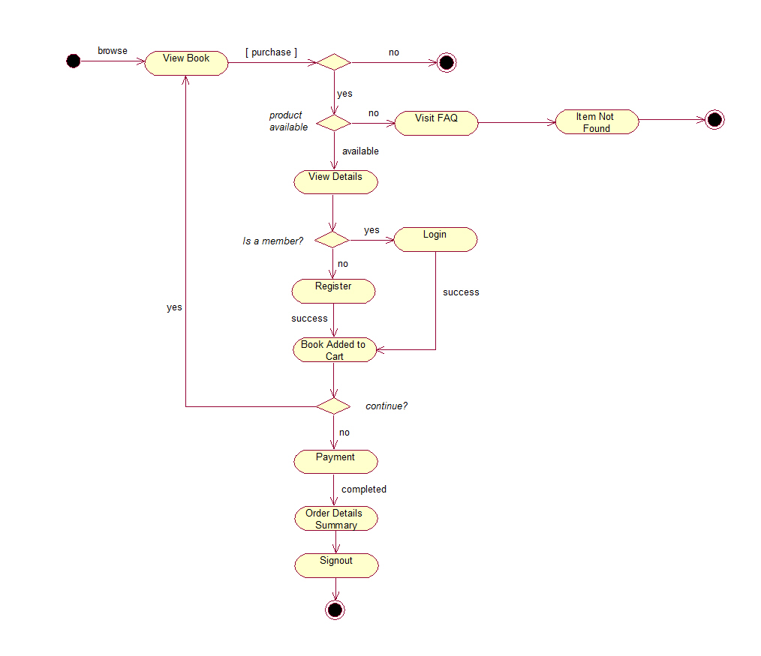

Figures 3.5 Activity diagram

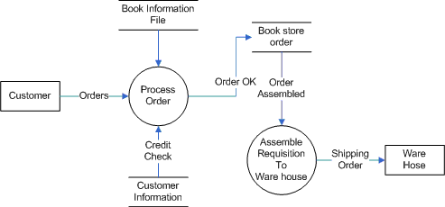

Figures 3.6 Activity Workflow

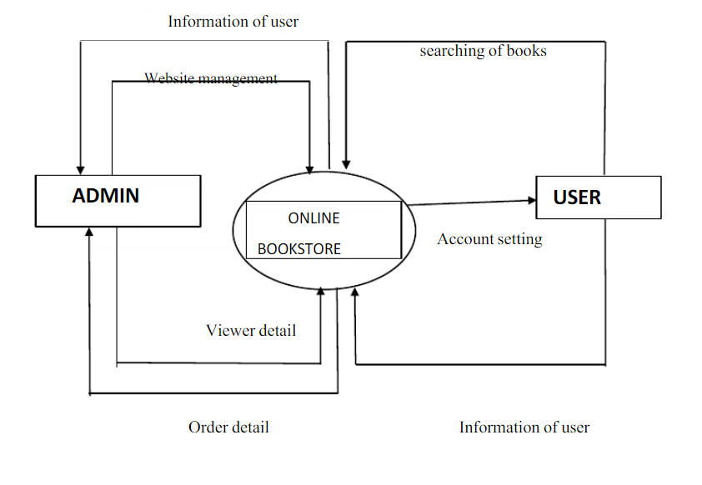

Figures 3.7 Activity Workflow

### Conclusion

In this chapter book ecommerce system is analyzed by different UML diagrams to find the actions, actors involved. Use case diagram shows the action required to complete the functions by different actors. Sequence diagram analyses the sequence and flow of information to complete different actions. On the other hand class diagram analyses the classes, attributes their operations and relationships between classes.

## CHAPTER 4

**PRODUCT DEVELOPMENT**

## Introduction

This chapter will cover how the management Book ecommerce system has been developed and what were the used methods and techniques all through the process of developing it. In developing of Book store system is complex systems and portals requires the collaboration and the teamwork of buyers, and book sellers of different backgrounds and knowledge in order to be able unite all the needed information into an outstanding outcome or product. The interest in Book store system has developed in the present, as the needs increased, and the use of internet become more corporate.

## Stages of Product Development

The development of the Book store system expired through a few phases, which had their significance in the advancement of the project. Those stages have supported in the following selected methodology and has secured the development of the project and somewhat made it go smooth in its period that was given to it. Each phase stated below shows the description and details of what has happened precisely in that phase and what it has manufactured as a conclusion.

## Resources gathering

The most important stage of all is first phase. If the first step is placed appropriately, it is going to be a right start for the rest of the project. The beginning of the project is made through resource gathering and data collection. In other words, the first few steps were contacting the major book stores to set up a meeting date for data collection from their end and to have a short interview with some of the staff members in order to know what they would like to have within the portal and what been missing.

## First Review of the Product

In this stage, some features of the website started to appear .This is useful because it made it easier to imagine the rest of the flow for the pages of the website and visualize the slightest and smallest details that me be in it. Customers gives feedback whether they find it easy to pick the desired Book, whether this system is fast and whether the system is providing all the necessary information or not.

## Second Review of the Adjustments

This is a critical stage of the project for the beginners, customers got jumbled about how to find the best desired Book, papers, journals for them based on the budget and the the authors. The biggest problem we have to face while buying a Book is customers do not know how other Books are costing. In other words, it was the most important step to develop a user-friendly environment for the user because some people collect money and then escaped.

## Product Verification

The finalized product was what has been expected to be in the integration of the website and the database has resulted in the production of the Management Portal. It’s capable to navigate through the pages of the website easily and efficiently, and as soon as the login or registration buttons are clicked, one is instantly directed to the login and registration page that is linked to the database. At the back-end from the staff’s side, Staff should be able to login into the system with valid email and password they can view and monitor the actions of the buyers and the logging in of the employees as well staff should be able to add new Books to manage existing details in the system. This is the home page of Book ecommerce system website from where user can find Books and their prices.

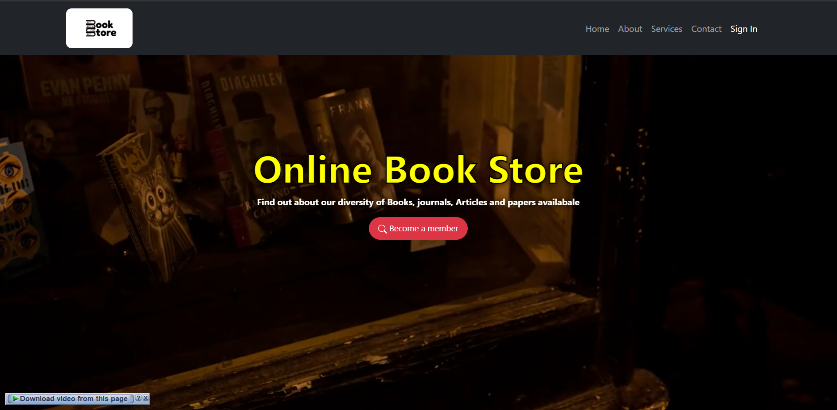

Figures 4.1: Home Page

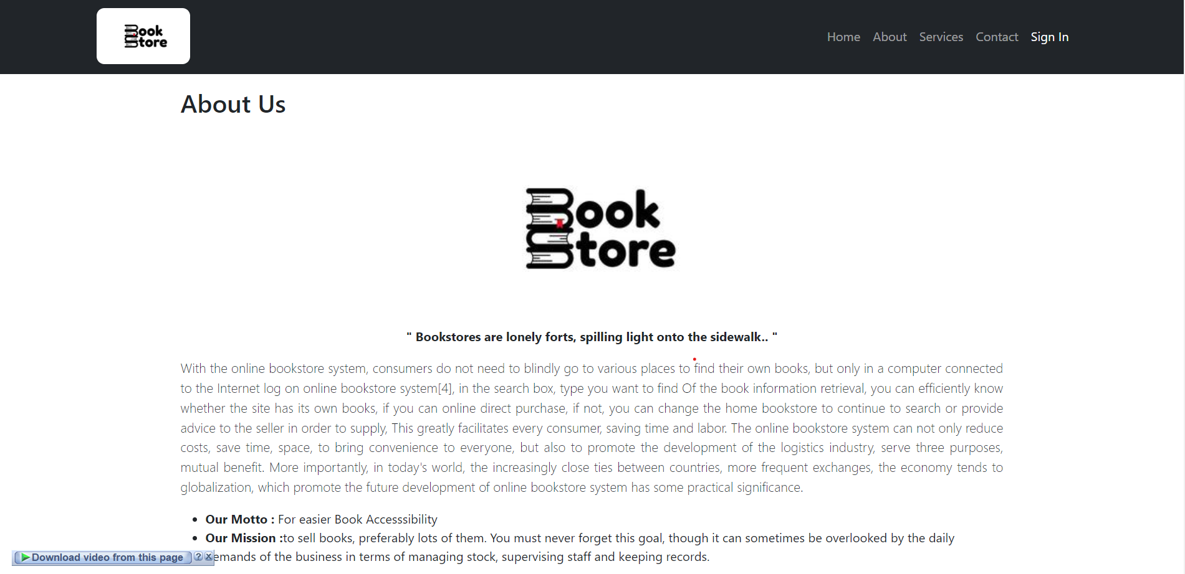

Figures 4.2 About Us

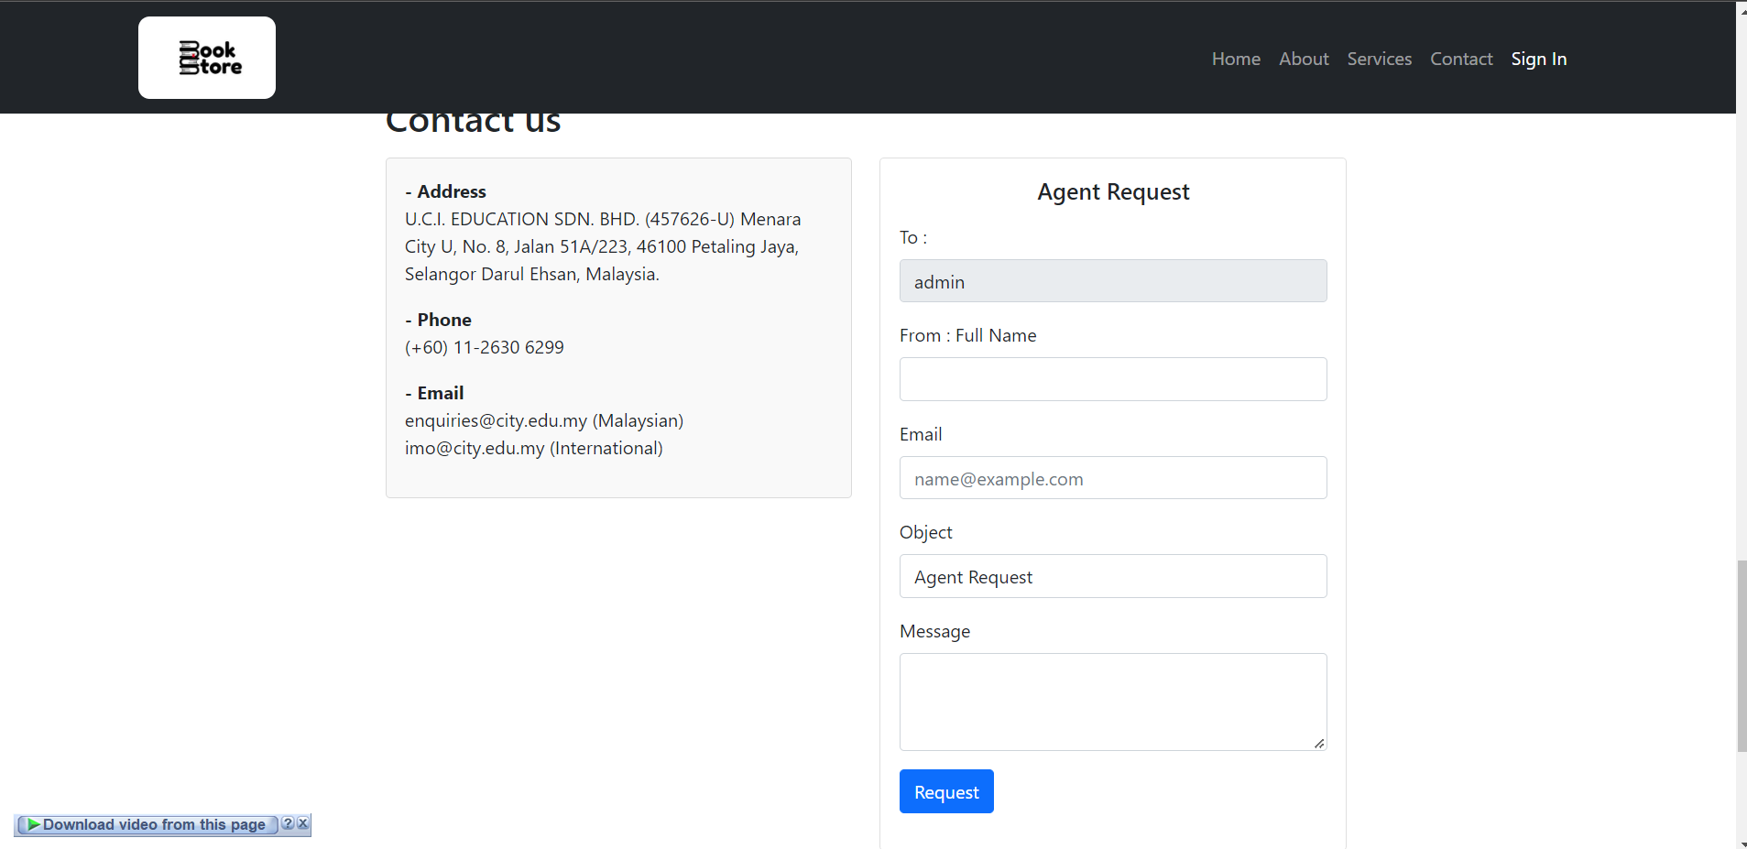

Figures 4.3 Contact us

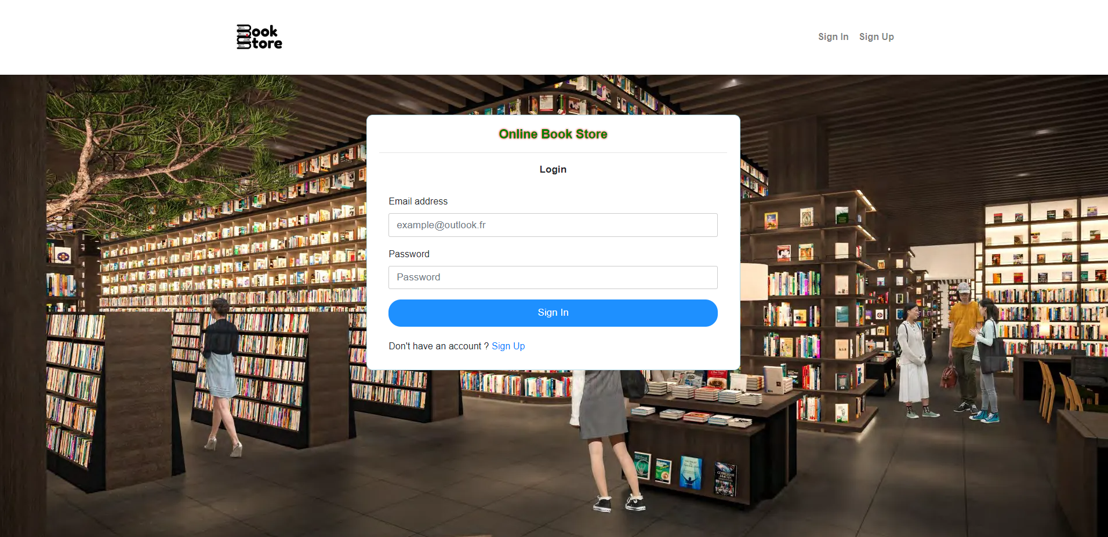

Figures 4.4 Login Page

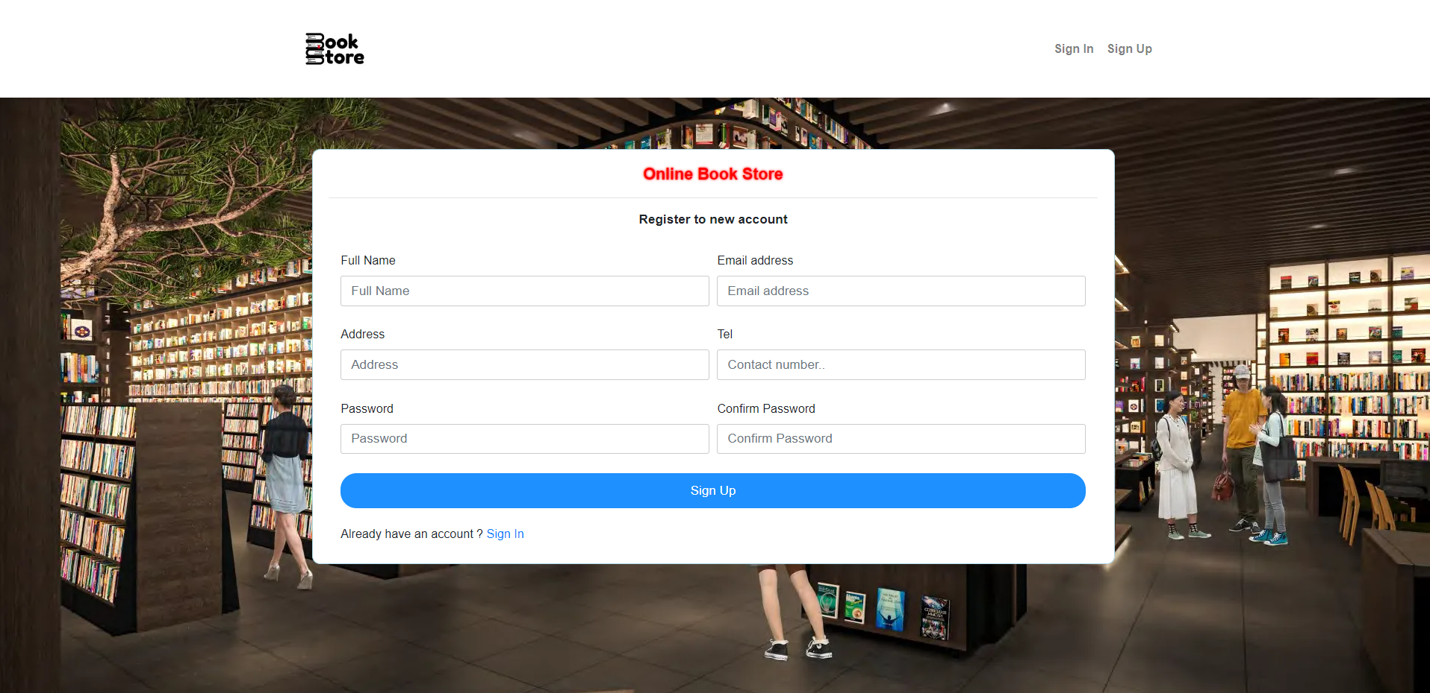

Figures 4.5 Registration Page

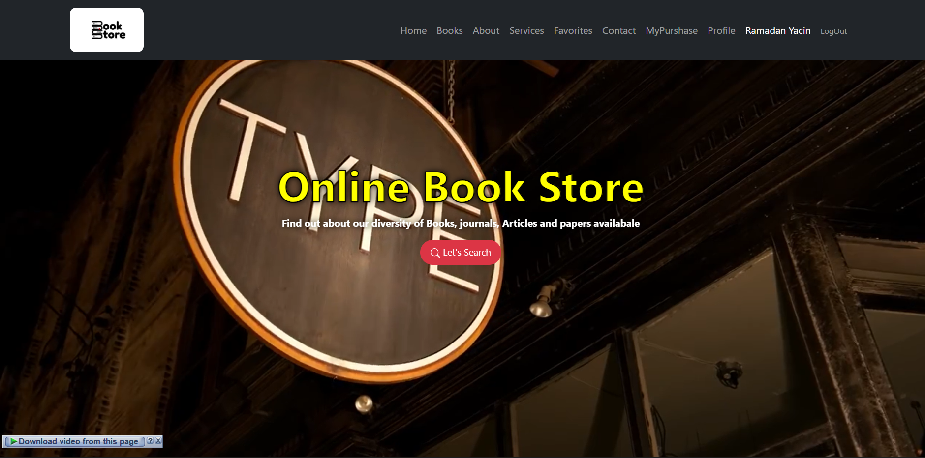

Figures 4.6 After Login Home Page

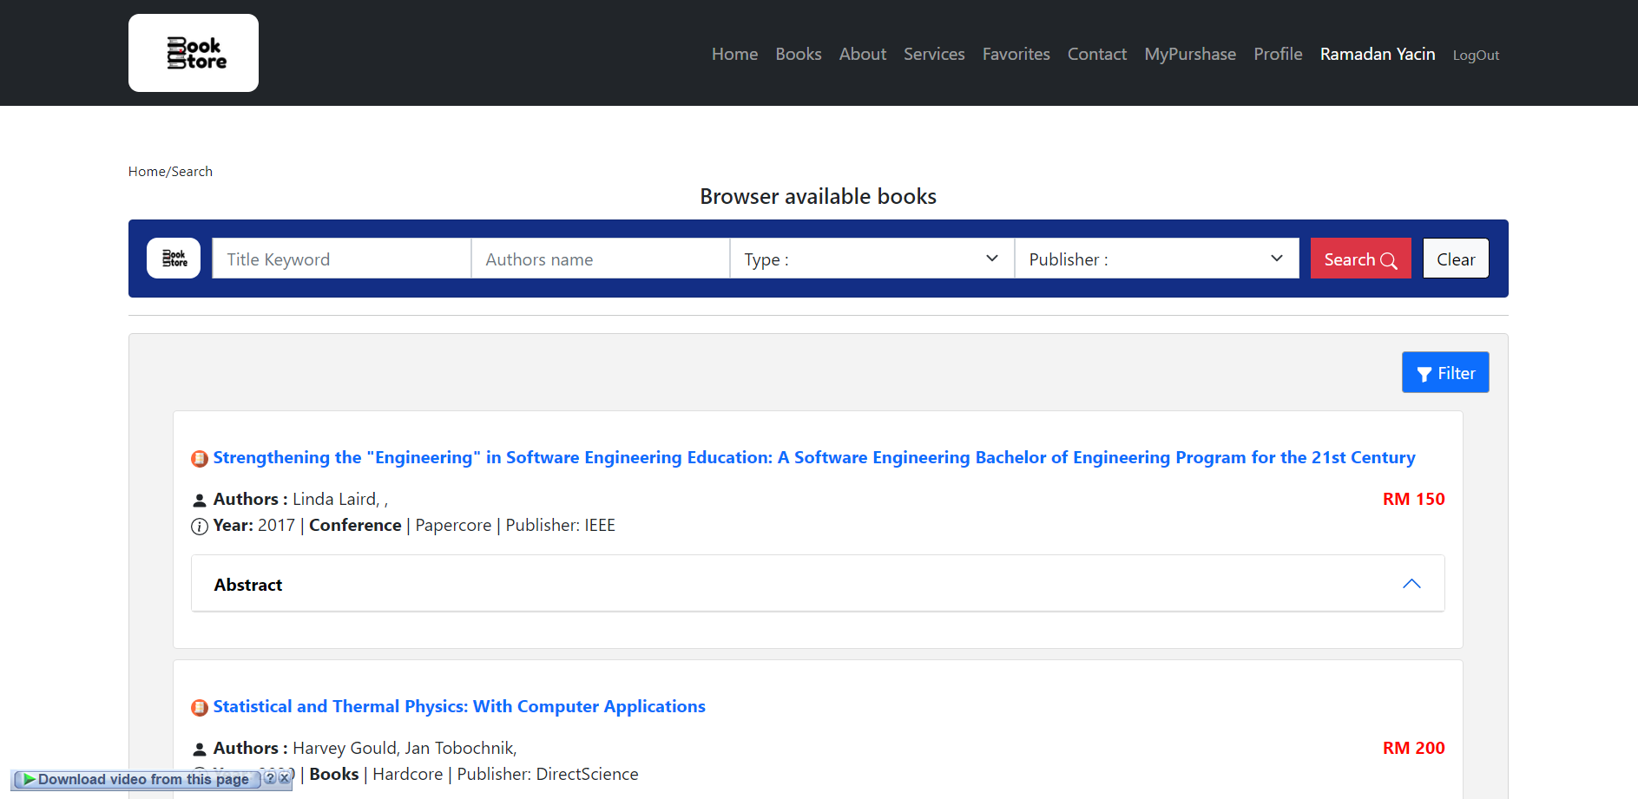

Figures 4.7 Search Books

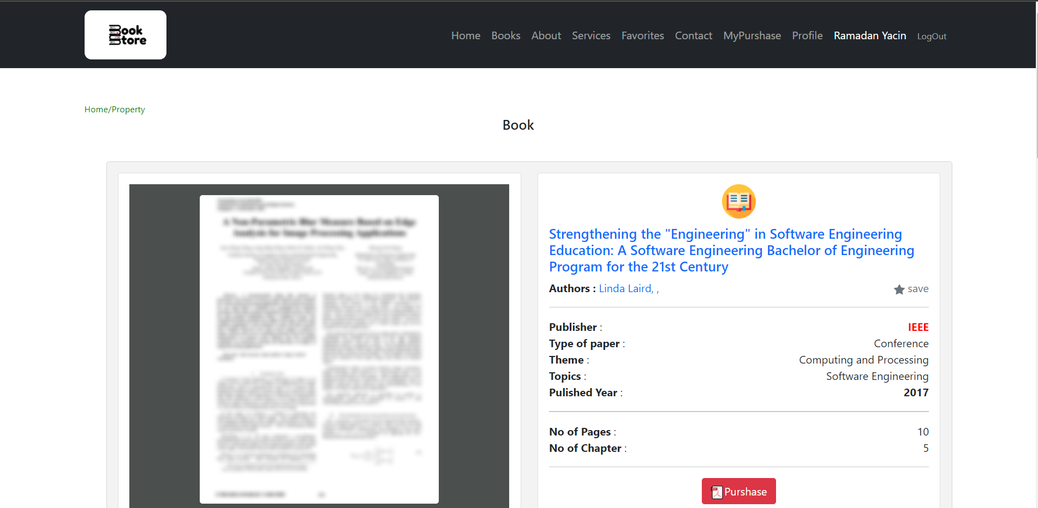

Figures 4.8 View Book

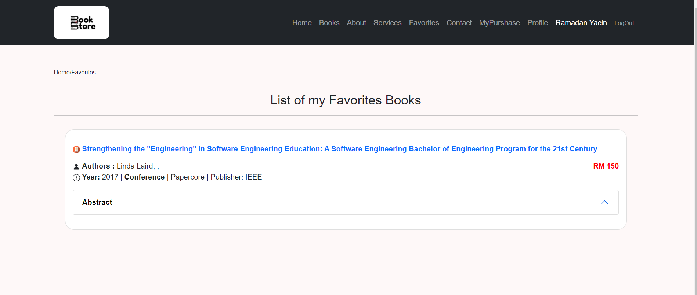

Figures 4.9 Favorite Page

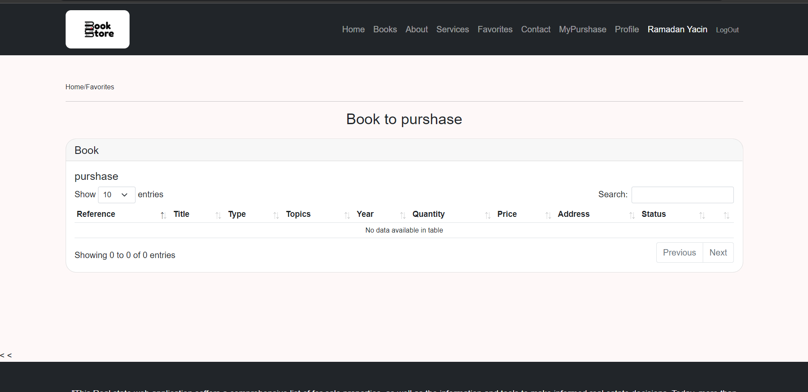

Figures 4.10 Book Purchased Page

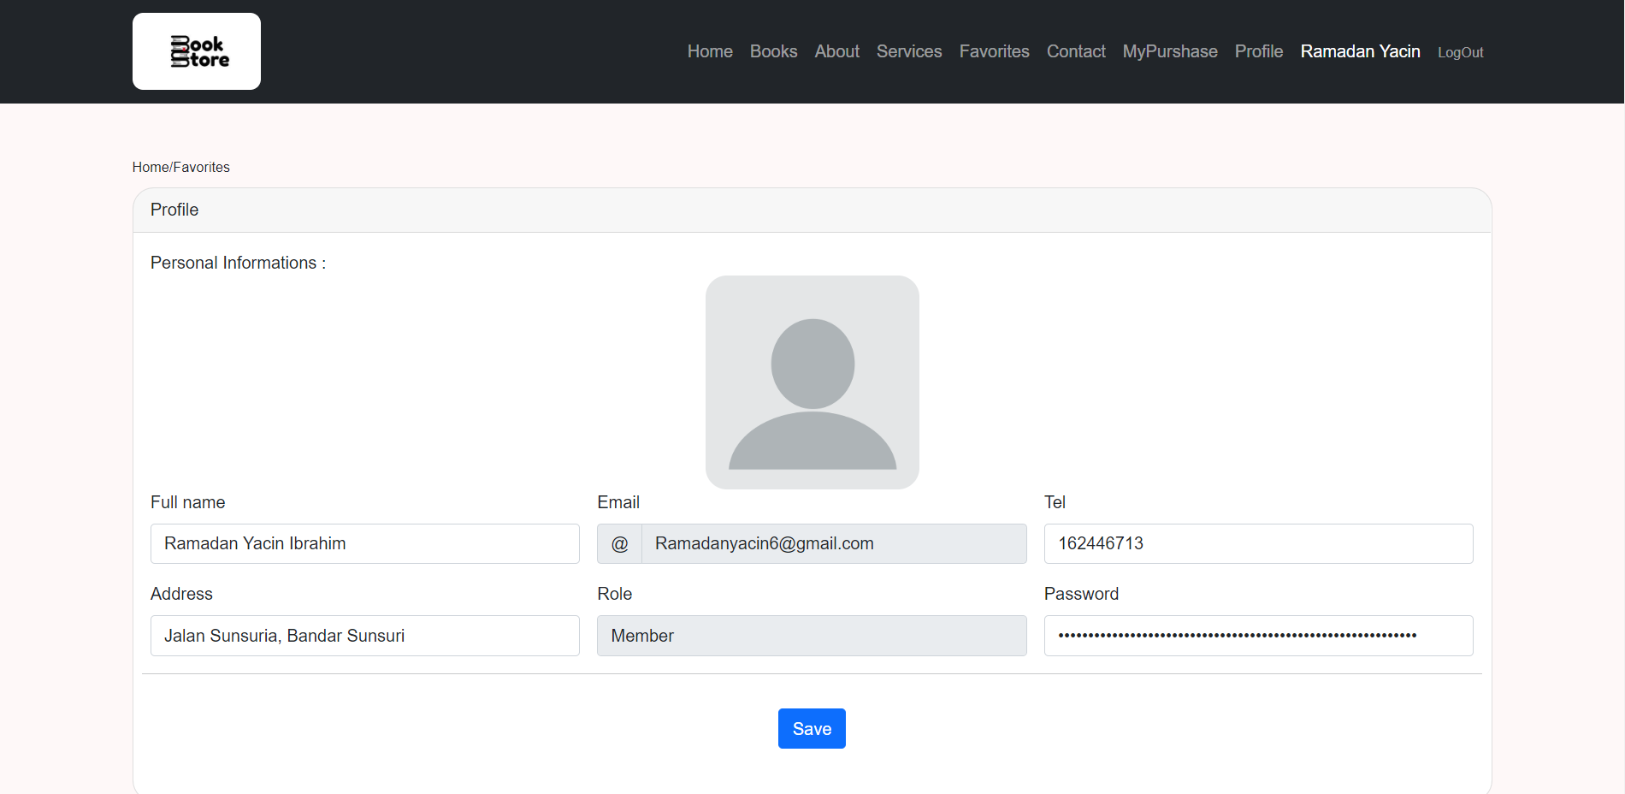

Figures 4.11 Profile Page

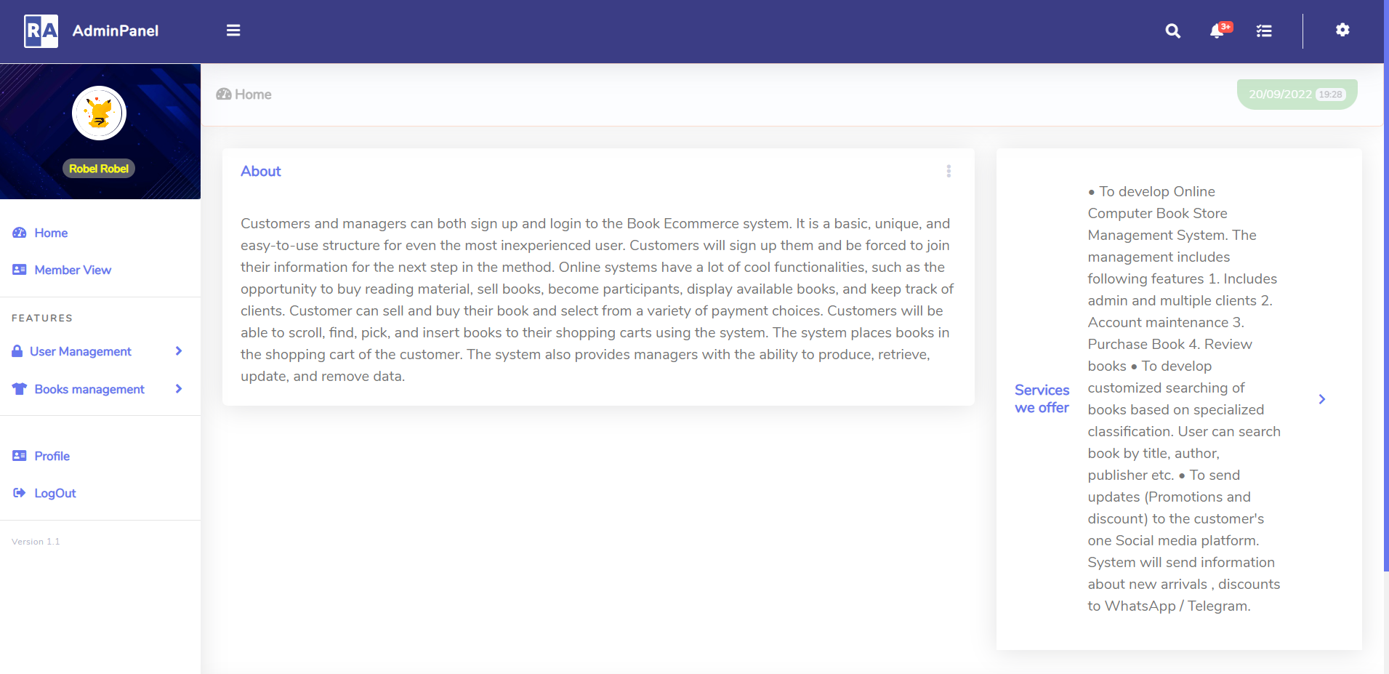

Figures 4.12 Admin Page

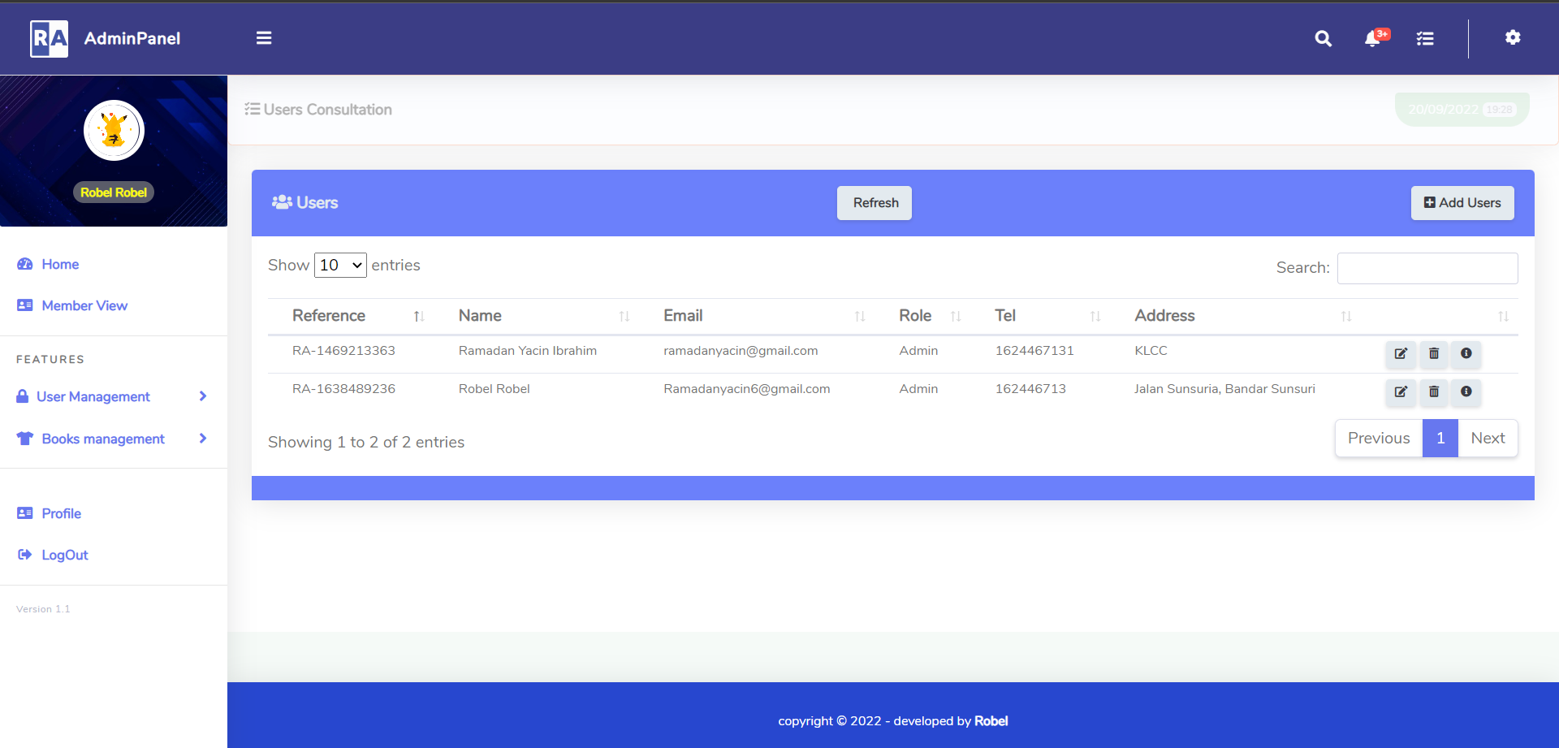

Figures 4.13 Manage Users Page

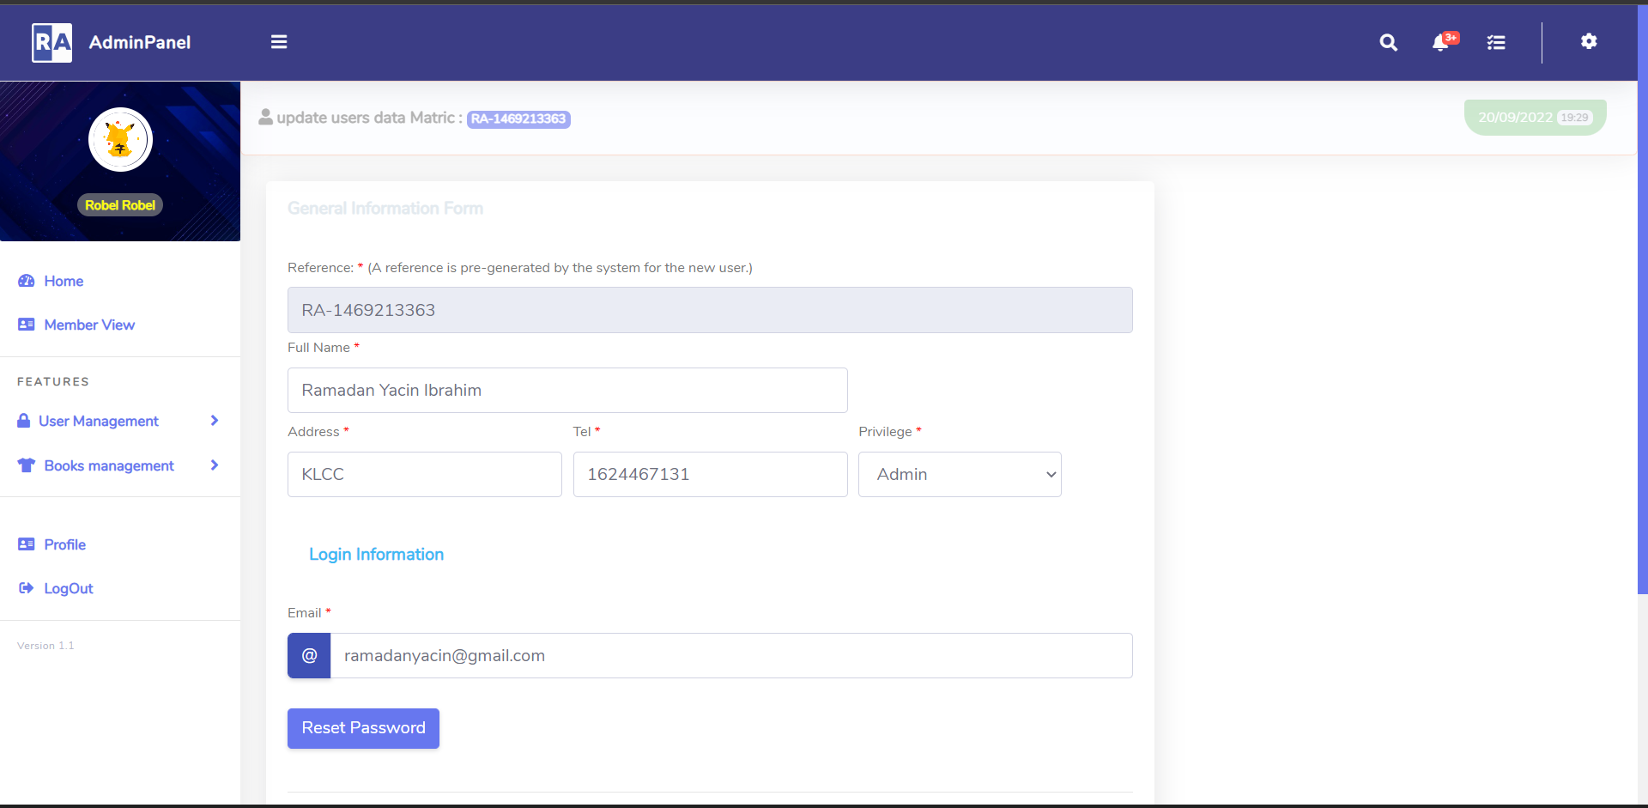

Figures 4.13 Edit Users Page

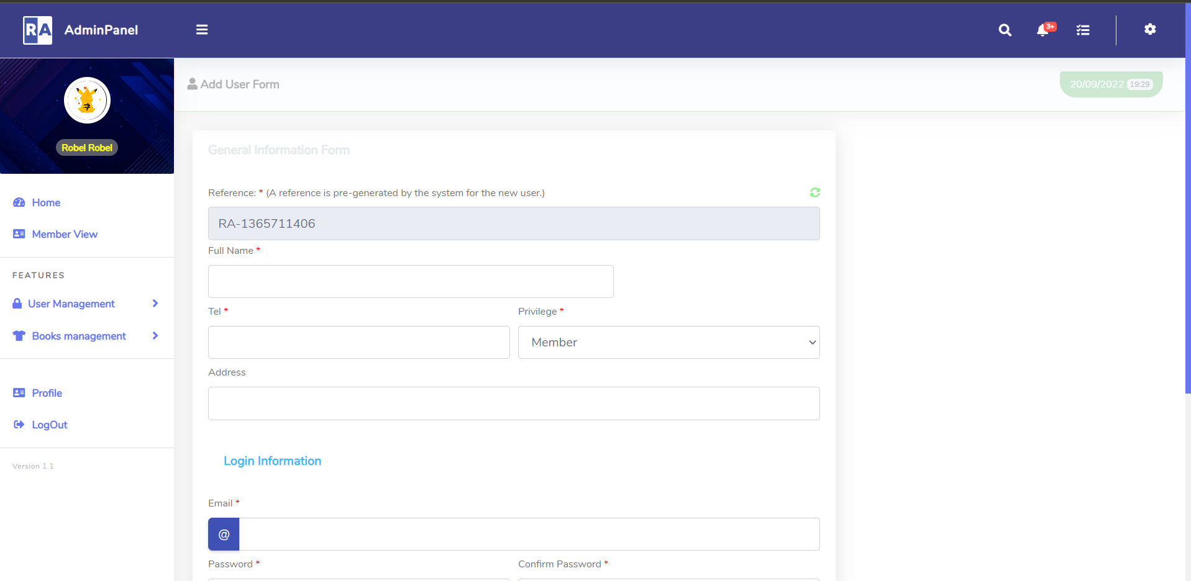

Figures 4.14 Add User Page

## Unexpected Outcomes/Limitations

Every action and plan that is drawn always meets in a way or another some sort of limitation or difficulty that causes the change of the course of events. In this project’s case, it was previously mentioned that one of the tools to be used for the development of the website was adobe Dreamweaver. Adobe Dreamweaver CC user is used to develop website and application.

Manipulate pixel perfect designs, craft complex code or do both with speed and grace. Adobe Dreamweaver CC create an experience that blend with CSS and JavaScript for best practice with layout compliance with the web standard for mobile device or desktop application. Dreamweaver is one such editor that has demonstrated itself to be an appropriate tool for the Web development task. However, due to some difficulties in learning this software two things replaced it: html and c# coding.

HTML and C# coding: this has proven to be one of the simplest, easiest and fastest ways to code and debug a website. C# is a general-purpose, multi-paradigm programming language encompassing strong typing, declarative, functional, generic, lexically scoped, object-oriented, and component-oriented programming disciplines. C# is cross platform programming language. It can be built .NET applications that can be deployed on Window, Mac, and Linux platforms As of previous knowledge of using those languages, it was quite facilitated to be able to convert the designs that were made on the HTML website that is fully clickable. It is invented to allow website creation. It helps creating the website and HTML goes hand in hand with PHP.

## Prevention and Minimization Factors of Unforeseen Outcomes

We choose the best platform tool which is suitable for our project. Some actions and acts that are to be taken to minimize future unforeseen outcomes is to actually make sure that all of the tools and software are available at reach and that the developer is at full skill in terms of its usage so that users can be productive and creative at their fields. We will try to overcome all the drawbacks which we noted in previous system and also get some good ideas from the previous projects that we will adopt to enhance our system.

## CHAPTER 5

**TESTING AND RESULTS**

* 1. **Testing Approach**

In this project rapid application approach is used for development and testing of the project. Rapid application testing approach enables us to test each developed module before moving on to the next module. In this testing method the whole project can be divided into modules and then each module can be developed and tested separately. In the first step whole project can be divided into increments and then they can be developed in parallel and at the end all the modules can be combined to get the whole functional product.

In this project separate increments are developed parallel because of the time constraints and then all were combined at the end. These modules are admin module, buyers module module. Functionality of each module is designed and tested separately and at the end all were integrated.

## Testing Strategy and Methods

Different testing methods are used for testing this Book store system. All these testing strategies are necessary to check the results of system to ensure that all features are working correctly on different platforms and there is no issue arising. So these testing strategies and methods are listed below

* + 1. Browser compatibility
    2. Platform compatibility
    3. System testing

## Browser compatibility Testing

It is necessary to perform browser testing for web applications; testing the system on different kind of browsers that are available. Testing was performed on various browsers. Detailed test report on the test performed is recorded in Table below they system should be responsive each browser

The base for testing of browser compatibility for Book store system is below.

* Objective: Find flaws, shape assurance and reduce risk in the compatibility between internet and browsers.
* Source: Design, architecture, schemas, dataflow, workflow
* Test types: Functionality testing, usage of resource, performance testing, reliability testing, usability and portability testing.
* Modules under test: Builds or backbones including subsystem’s database implementation, infrastructure, interfaces, configuration data.
* Answerable: Testers and programmer are responsible for testing.

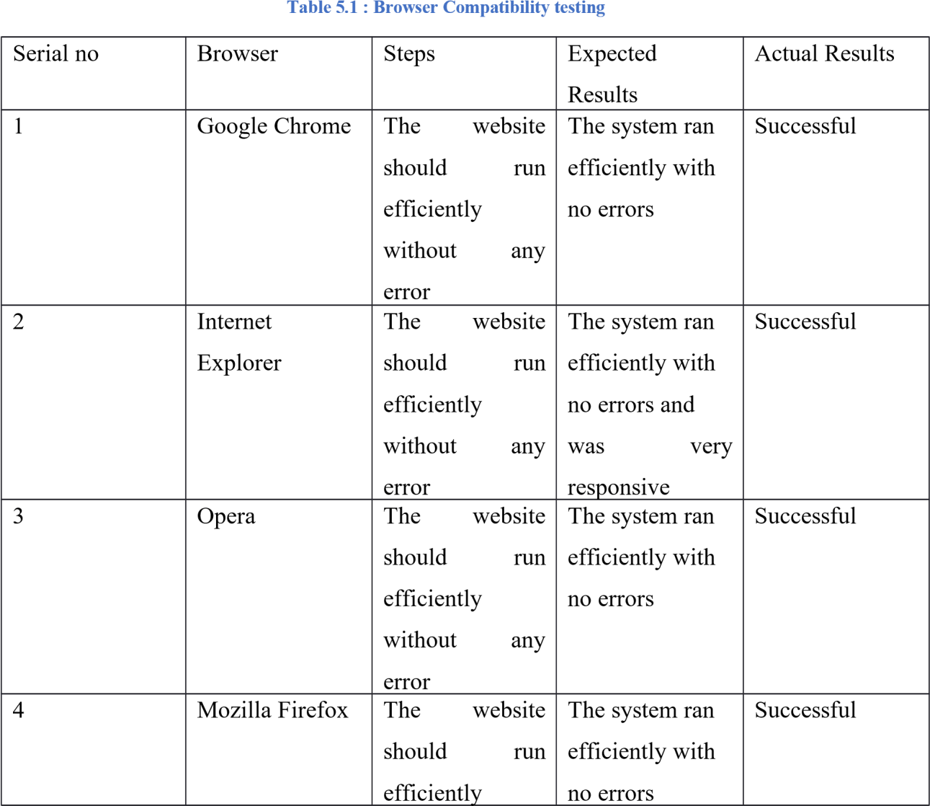

## Platform compatibility Testing

The purpose of this testing method was to figure whether the website is running smoothly on different types of operating system, or it is platform dependent.

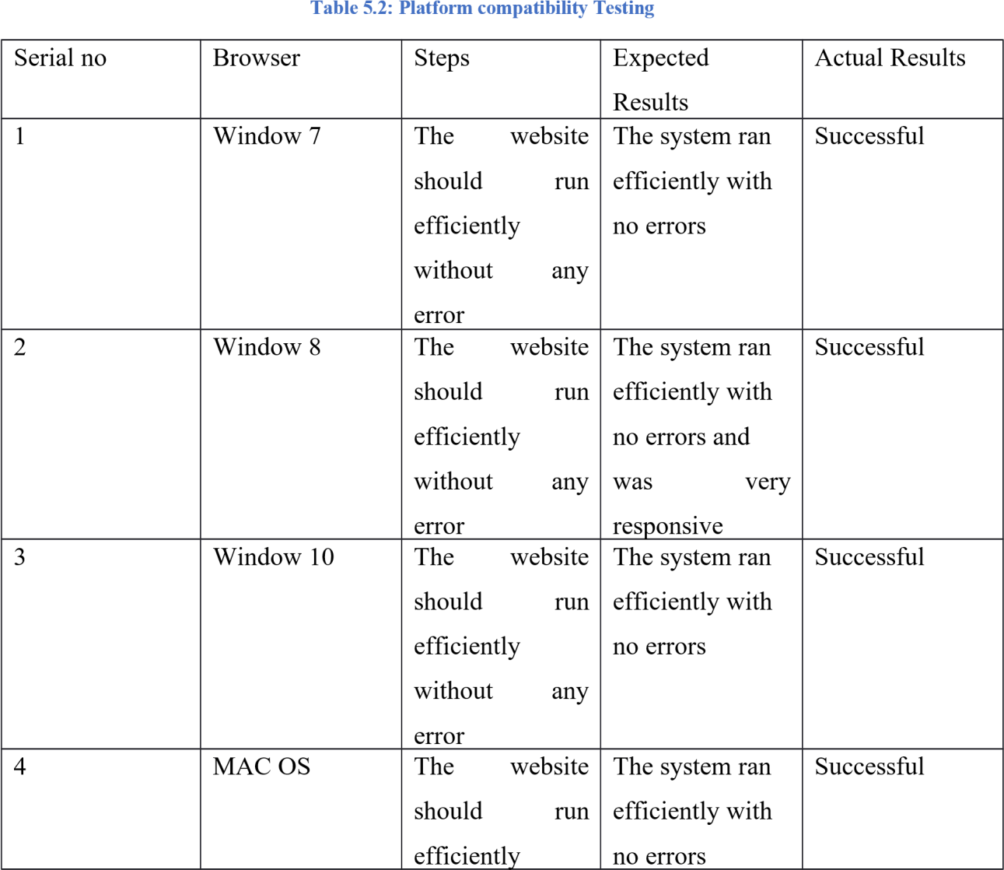

## System Testing

Black box testing method was used for the system testing. This method of testing is used because the internal workings of the system being tested are not known by the tester. The tester only knows the inputs and what the expected outcomes should be and not how the program arrives at those outputs. The tester does not ever examine the programming code and does not need any further knowledge of the program other than its specifications. Some of the advantages of using black box testing are:

* The test is unbiased because the designer and the tester are independent of each other.
* The tester does not need knowledge of any specific programming languages.
* The test is done from the point of view of the user, not the designer.
* Test cases can be designed as soon as the specifications are complete

The objective of this testing is to check that whether the system is fully functional and based on the requirement of system. In this step it is necessary to check the results of test cases that were designed before implementing the system.

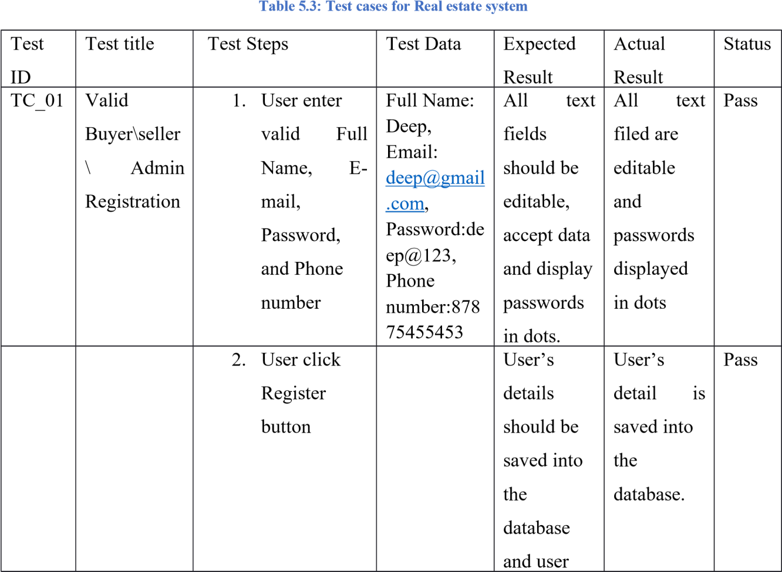

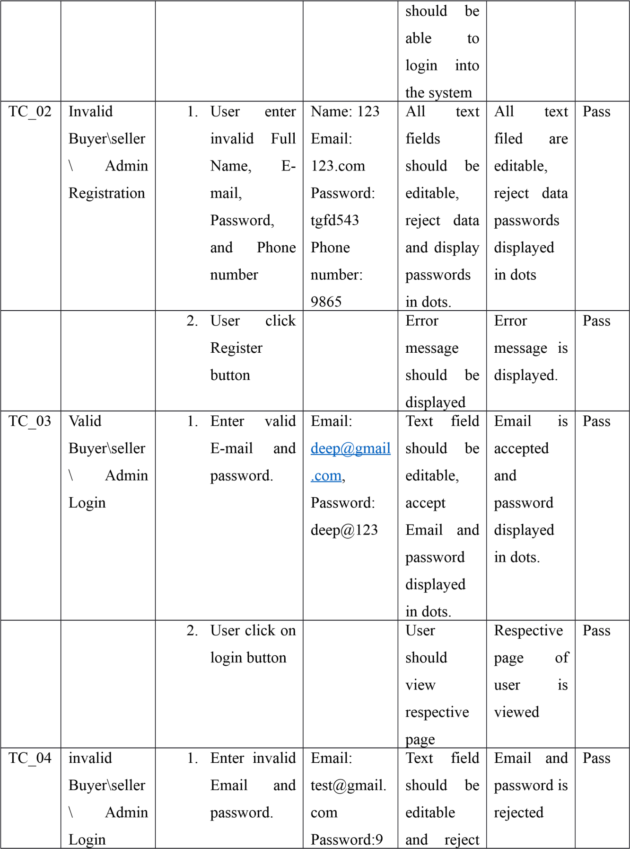

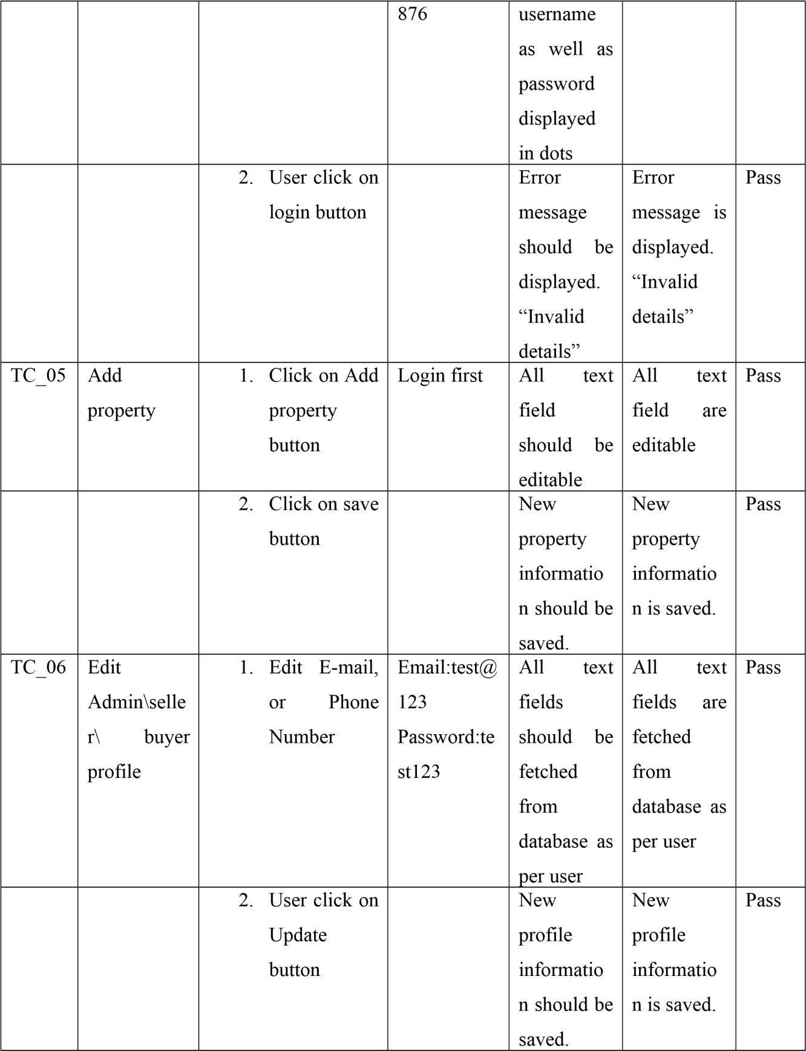

Book

Book

Book

## 5.3. Conclusion

Different testing methods were applied to make sure that all the modules of Book store website are working appropriately following all the required test were conducted using different test cases to guarantee that clients expected confidence about the website has been built. The system works perfectly on most major browser like Google chrome, Firefox, Internet explorer and Opera. Moreover, the system is compatible with windows and MAC operating system.

## CHAPTER 6

**CONCLUSION**

* 1. **Introduction**

Online Book Store is an online Book Store software application that achieves the overall working activities and processes. The Book Store systems system has grown in the present, as the needs increased, and the use of internet become more common. Online Book Store has supported to be a positive effect of all users. This is a basic system where users can register then login ,purchase and manage Book. Through a web browser the customers can search for a book by its title or author, later can add to the shopping cart and finally purchase using credit card transaction. Whether they are looking for entertainment, information or to shop, smart devices and computers are a convenient ‘go-to’ for the modern customer – and with the current COVID-19 situation, this trend is gathering even more momentum.

Consider your own purchasing Books. With the simple click of a button, it’s so easy to order food and stream movies online from the comfort of your own home, especially during the current social distancing restrictions.

Book stores are no exception to this growing trend. While brick-and-mortar stores will always have their place, expanding your store to include an online shop may be a wise decision to help you adapt and thrive in this evolving market.

Online Book Store systems will help the users to process fast and also remove the overhead documents. In this system users can register, purchase, and view Books. The whole system will be managed by the admin and give the facilitation to the users to communicate with each other and if needed it.

## Accomplishments of Objectives

At the start of this project, some objectives were set to be met as the project improvements and develops. Finally, those objectives have been accomplished through the management portal for Malaysian Association of Book stores.

* + 1. **Objective 1: To develop Online Computer Book Store Management System. The management includes following features**

Consequently, the seller-buyer management system has been developed for the Online Book Store management system. Seller communicate buyer and buyer can request to contact the publisher for interested Book. Online Book Store system will provide communication facilities between buyers and sellers and allow both of them to provides your avid readers with a simple and easy option to make purchases. Through your website, they can browse your titles anytime and anywhere, and simply click “buy” when they’re ready. The convenience and immediacy of this experience encourage more purchases, as they won’t need to leave the safety and comfort of their homes

* + 1. **Objective 2: To develop customized searching of books based on specialized classification. User can search book by title, author, publisher etc.**

The internal network is built as a client-server network, which means that a server has been set to accept clients for the verification of the users in the system, making enable user to find This and create user-friendly interfaces for e-shops, portfolios or photo galleries. When an item is selected, a description rolls up with a smooth effect. Also, the view is fully responsive on any device.

* + 1. **Objective 3: To send updates (Promotions and discount) to the customer's one Social media platform. System will send information about new arrivals , discounts to WhatsApp / Telegram.**

The Admin have the ability to send the latest discounts and any update made by the representing store. Administrators support the smooth running of offices by carrying out clerical tasks and projects. As an administrator in the construction industry, you could be organising project meetings. You'd be typing up documents, responding to business enquiries, drawing up contracts and providing customer service.

## Summary of Findings

This chapter comes up to be the most important chapter of all as it summarizes and puts together all of the above details in an organized and summarized manner to be able to view the whole perspective and view of this project.

This management portal had three crucial parts, which were the website, database, and the internal communication system of the Online Book Store. The integration of those parts has been a long journey, but a success and it is to be implemented in the Online Book Store for everyone to use and navigate through it easily.

## Challenges Faced

At first it was hard to manage and understand how things will continue as my project is depending on extreme programming methodology which means that I have to go back to the third part for confirmation at every step so that time and effort is saved. This had taken from my time I tried to get back as fast to my progress to catch up on what I have missed in my development of my project.

The limitations are:-

Cannot be used without internet.-

Users cannot give feedbacks.-

Limited books are only available.-

Error in spelling by the user cannot provide the exact book they want.

## Future Works

While interpreting the results and formulating any future plans for research or improvement in the Online book store, future researchers and developers need to lookout for any future restrictions or any new advancement in the technological world.

## Conclusion

The system is a general hobby for reading and books on the needs of the consumer customer base, with a certain degree of practical online bookstore system. It is mainly different from the traditional physical bookstores, to overcome a series of physical bookstores limited variety, fixed location, limited space and narrow sales channels and other issues, for people to purchase the book has brought convenience. Online bookstore system not only can easily find the information and purchase books, and the operating conditions are simple, user-friendly, to a large extent to solve real-life problems in the purchase of books, but the design of the system because of the completion time of the restrictions, some of the functions of the system is not perfect, but the basic functions have been achie

**References**

Y. Wang and D. Xu, "Research on the Business Model Innovation of Sisyphe Bookstore under background of New Retail," 2021 2nd International Conference on E-Commerce and Internet Technology (ECIT), 2021, pp. 99-102, doi: 10.1109/ECIT52743.2021.00029.

Ming Cui and Jiali Yu, "Service Innovation in the Transformation of Physical Bookstores in the Retail 4.0 Era – Based on the Service Quality Gap of Bookstores [J]", Science-Technology and Publication, no. 01, pp. 95-102, 2020.

Electronic Transactions Development Agency. (2019). The announcement of the 2019 Internet user behavior survey in Thailand. Retrieved June 1, 2020 from <https://www.etda.or.th/documentsfor-download.html>

Wheelen, T. L., Hunger, D. J., Hoffman, A. N., & Bamford, C. E. (2017). Strategic Management and Business Policy: Globalization, Innovation and Sustainability. 15th Edition. New York: Pearson Education.

Jie Liu.Design and Implementation of Online Bookstore Based on JSP and JavaBean Technology.Modern Information,2015,(12):42-47.

Lingxi Meng.Design of Online Bookstore System Based on B2C Model.Value engineering,2011,(36):101-102.

Yingqian Tan.Research on Evaluation Index System of Online Bookstore Based on University Students' Satisfaction.Journal of Sun Yat-sen University (Social Science Edition),2011,(4):174-184.

Yinghui Xu.Design and Realization of Online Used Book Sale System.Consumer Electronics,2012,(9):67-68. 5. Zhuanhong Chen,Huan Li.A typical application of jQuery in WEB query module.Electronic Technology,2013,(12):28-32. 6. Paz J R G. Ajax and jQuery.Beginning Asp Net Mvc,2013,(3):11-13.

Dan Deng.The Operating Mode and Development Prospect of China 's Online Bookstore.Entrepreneur World,2013,(4):110-111.

Ms. Pragati Bagmare1 , Ms. Shraddha Girhepunje2 , Ms. Priya Bisen, “Research Paper on Online Bookshop Management System”, International Journal for Research in Applied Science & Engineering Technology (IJRASET), Volume 5., Issue 4., 2017, page no. 115-117.

Fatin Najwa Binti Abdullah Sani1 , Hani Malini binti Majek2 , Umairah binti Ahmad Khairudin3 , Abdul Rahman bin Ahmad Dahlan4, “e-Bookstore: Opening Door to the Garden of Knowledge”, International Journal of Scientific and Research Publications, Volume 7, Issue 6, June 2017 ,page no. 2250-3153

Vamsi Krishna Mummaneni ,A Report Submitted in partial fulfillment of the requirements of the degree of Master of Software Engineering.

M. Benedikt, J. Freire, and P. Godefroid. Veriweb: Automatically testing dynamic web sites. In Proceedings of 11th International World Wide Web Conference, Honolulu, Hawaii, USA, 2002. Appears in ACM SIGSOFT Software Engineering Notes 29(5):1-10, 2004. Show in

D. W. Binkley. The application of program slicing to regression testing. Information and Software Technology Special Issue on Program Slicing, 40(11 and 12):583-594, 1998.



S. Elbaum, G. Rothermel, S. Karre, and M. Fisher II. Lever-aging user-session data to support web application testing. IEEE Transactions on Software Engineering, 31(3):187-202, Mar. 2005.



T. Graves, M. J. Harrold, J.-M. Kim, A. Porter, and G. Rothermel. An empirical study of regression test selection techniques. In Proceedings of the 20th International Conference on Software Engineering, pages 188-197. IEEE Computer Society Press, Apr. 1998.



R. Gupta, M. J. Harrold, and M. L. Soffa. An approach to regression testing using slicing. In Proceedings of the IEEE Conference on Software Maintenance, pages 299-308, Los Alamitos, California, USA, 1992. IEEE Computer Society Press.



S. Karre, S. Elbaum, and G. Rothermel. Improving web application testing with user session data. In Proceedings of the 25th International Conference on Software Engineering, pages 49-59, Portland, Oregon, USA, May 2003.

T. Margaria, O. Niese, and B. Steffen. A practical approach for the regression testing of IP-based applications. In IP Applications and Services 2003: A Comprehensive Report, pages 195-208. International Engineering Consortium (IEC), 2002.

R. C. Miller and K. Bharat. Sphinx: a framework for creating personal, site-specific web crawlers. In Proceedings of the seventh international conference on World Wide Web 7, pages 373-388, Brisbane, Australia, 1998. Springer-Verlag.

S. Raghavan and H. Garcia-Molina. Crawling the hidden web. In In Proceedings of the 27th International Conference on Very Large Data Bases, pages 129-138, New York, NY, USA, 2001.



F. Ricca and P. Tonella. Analysis and testing of web applications. In Proceedings of the 23rd International Conference on Software Engineering, pages 25-34, Toronto, Ontario, Canada, 2001. IEEE Computer Society.

F. Ricca and P. Tonella. Building a tool for the analysis and testing of web applications: Problems and solutions. In Proceedings of the 7th International Conference on Tools and Algorithms for the Construction and Analysis of Systems, pages 373-388. Springer-Verlag, 2001.



G. Rothermel, R. Untch, C. Chu, and M. J. Harrold. Prioritizing test cases for regression testing. Transactions on Software Engineering, 27(10):929-948, Oct. 2001.

S. Sprenkle, E. Gibson, S. Sampath, and L. Pollock. Automated replay and failure detection of web applications. In Proceedings of International Conference on Automated Software Engineering (ASE 2005), pages 253-262, Long Beach, California, USA, 2005.

P. Tonella and F. Ricca. Statistical testing of web applications. Journal of Software Maintenance, 16(1-2):103-127, 2004.

L. Xu, B. Xu, Z. Chen, J. Jiang, and H. Chen. Regression testing for web applications based on slicing. In COMPSAC, pages 652-656, 2003.

Anderson, C. (2007). *The long tail: How endless choice is creating unlimited demand*. London: Random House Business.

Brynjolfsson, E., Hu, Y., Smith, M. (2003). Consumer surplus in the digital economy: estimating the value of increased product variety at online booksellers. *Management Science, 49*(11), 1580–1596.

Brynjolfsson, E., Hu, Y., Smith, M. (2006). From niches to riches: anatomy of the long tail. *MIT Sloan Management Review, 47*(4), 67–71.

Chevalier, J., & Goolsbee, A. (2003). Measuring prices and price competition online: [Amazon.com](http://www.amazon.com/) and [BarnesandNoble.com](http://www.barnesandnoble.com/). *Quantitative Marketing and Economics, 1*(2), 203–222.

Chou, C.F., & Shy, O. (1990). Network effects without network externalities. *International Journal of Industrial Organization, 8*(2), 259–270.

Clay, K., Krishnan, R., Wolff, E., Fernandes, D. (2002). Retail strategies on the web: price and non-price competition in the online book industry. *Journal of Industrial Economics, 50*(3), 351–367.

Dixit, A.K., & Stiglitz, J.E. (1977). Monopolistic competition and optimum product diversity. *American Economic Review, 67*(3), 297–308.

Forman, C., Ghose, A., Goldfarb, A. (2009). Competition between local and electronic markets: how the benefit of buying online depends on where you live. *Management Science, 55*(1), 47–57.

Hotelling, H. (1929). Stability in competition. *Economic Journal, 39*(153), 41–57.

Mellahi, K., & Johnson, M. (2000). Does it pay to be a first mover in e.commerce? The case of [Amazon.com](http://www.amazon.com/). *Management Decision, 38*(7), 445–452.

Neven, D., & Thisse, J.F. (1990). On quality and variety competition. In J.J. Gabszewicz, J.F. Richard, L. Wolsey (Eds.), *Economic decision making: Games, econometrics, and optimization* (pp. 175–199). North-Holland, Amsterdan.

Peng, S.K., & Tabuchi, T. (2007). Spatial competition in variety and number of stores. *Journal of Economics & Management Strategy, 16*(1), 227–250.

Sorensen, A. (2007). Bestseller lists and product variety. *Journal of Industrial Economics, 55*(4), 715–738.

Higgins, Ron. "E-Commerce: Report From The Trenches," http:/ lwww. beyondcomputingmag. com. September 1999.

Hilderbrandt, David. "10 Tips fore-transformation," http://www. beyondcomputingmag. com/archive/ 1999/08-99/frontline. html. October, 1999.

Matozzo, Michele. "Online Bookstore Story". http://www.aip.org/epn/sep95/article 7. html. September, 1995.

Microsoft Visual InterDev 6.0 Programmer's Guide Washington: Microsoft Press, 1998. 19. Morris, Charlie. "Developing Databases For the Web and Intranets". http://www. webdevelopersjournal. com/books/developing_ databases. html. October 27, 1999

Morris, Bruce. "Developing Large Commerce-Oriented Web Sites" . http://Webdevelopersjournal. com/articles/commerce. htm. October, 1997.

Mueller Paul and Torn Sheldon. Microsoft Internet Information Server 4 California: Osborne, 1998. 22. Murray, James. "Shopping Cart Software" . http://Webdevelopersjournal.com/software/shopping.html. October 13, 1997.

Reinshagen, Dirk. "Inside ASP" http://www. Webreview.com/pub/97/1112I/feature/sidebar.html. November 27, 1997.

"Relational Database". www. whatis.com. February 2000. 25 . Rosenfeld, Louis and Peter Morville. Information Architecture for the World Wide Web. California: O'Reilly & Associates, 1998.

Special CNET News "Analyst: E-commerce growth will beat forecasts" http://www.news. com/News/item/0,4,37350,00.html. June 3, 1999.